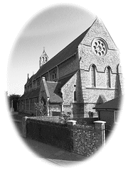 | ALL SAINTS CHURCH  Perry Street, Northfleet, DA11 8RD  FORTHCOMING EVENTS

DECEMBER

Monday 9th | 9.30 a.m. | Walsingham Mass with Healing Ministries
Saturday 14th | 12.30 p.m. | Church Choir sing Carols for Christian Aid  in St George’s Centre, Gravesend,
 | 2.00 p.m. | Afternoon Tea and Carols  in aid of Demelza House
Saturday 21st | 6.00 p.m. | Nine Lessons and Carols Service  The Traditional Carol Service
Tuesday 24th | 3.00 p.m. | Crib and Christingle Service  Children may come dressed as Nativity characters  Collection taken for the Children’s Society
 | 11.30 p.m. | Mass in the Night
Wednesday 25th | 10.00 a.m. | Mass in the Day
Friday 27th | 7.30 p.m. | St John’s, Higham, Patronal Festival Mass
Saturday 28th | 10.00 a.m. | “Get over Christmas” Coffee morning

JANUARY 2025
Wednesday 1st | 10.00 a.m. | Mass  The Solemnity of Mary, Holy Mother of God
Sunday 5th | 10.00 a.m. | Parish Mass The Epiphany of the Lord
Saturday 11th | 9.30 a.m. | Walsingham Mass with Healing Ministries
Sunday 12th | 10.00 a.m. | Parish Mass The Baptism of the Lord  (The last day of Christmas-tide)
Saturday 18th | 10.00 a.m. | Saturday Cuppa with Tombola & Monthly Draw
FEBRUARY
Saturday 1st | 10.00 a.m. | Saturday Cuppa with Tombola & Monthly Draw
Saturday 8th | 9.30 a.m. | Walsingham Mass with Healing Ministries
Saturday 15th | 10.00 a.m. | Saturday Cuppa with Tombola

MARCH 2025

Saturday 1st | 10.00 a.m. | Saturday Cuppa with Tombola & Monthly Draw
Saturday 8th | 9.30 a.m. | Walsingham Mass with Healing Ministries
Wednesday 5th Ash Wednesday | 9.30 a.m.  7.30 p.m. | Mass (with Ashing)  Mass (with Ashing)
Day of Fasting and Abstinence
Saturday 15th | 10.00 a.m. | Saturday Cuppa with Tombola
Tuesday 25th | 10.00 a.m. | Mass
The Annunciation of the Lord

Saturday 29th | 11.00 a.m. | Children’s Crafts and Activities

APRIL

Saturday 5th | 10.00 a.m. | Saturday Cuppa
Sunday 6th | 5.00 p.m. | Richborough Family Service of Penitence
Tuesday 15th | 12.00 p.m. | Richborough Chrism Mass  at Rochester Cathedral
Maundy  Thursday 17th | 8.00 p.m. | Liturgy of the Last Supper
Good  Friday 18th | 2.00 p.m. | Solemn Liturgy of the Cross
Holy  Saturday 19th | 9.00 p.m. | Vigil and First Mass of Easter
Easter  Sunday 20th | 10.00 a.m. | Parish Mass

Usual Weekly pattern at All Saints

Sunday
10.00 a.m. Parish Mass

Tuesday
9.30 a.m. Mass

Wednesday
10.00 a.m. Little Lambs
Story, crafts and play for pre-school children, with a time of refreshments.

Thursday
9.30 a.m. Mass

For full details of all our services please visit
www.allsaintsperrystreet.org
- All Saints Perry St

AllSaintsChurchPerryStreet

We currently have no full time Priest. We are grateful to all who help support All Saints with their many different skills, not least our three Retired Priests who maintain our Services. We are always open to more volunteers coming forward.

For Church matters please contact the Churchwardens, for Spiritual matters or for the Sacrament of Reconciliation (Confession) please contact Fr James, Fr Simon or Fr Lindsay. To book a Wedding or Baptism or for General Enquiries contact Martin our Parish Administrator.

A SIMPLE WAY TO ADD TO OUR FUNDS - You can register for Easyfundraising, and the companies you use will donate to us at no cost to you. https://join.easyfundraising.org.uk/all-saints-perry-street/f4iqq0/c2s/ gZ6MRT9B/Q2246/ facebook/


One way in which you can donate towards All Saints is by using our QR code.

If you are a UK Taxpayer, you can increase your donation, at no extra cost to yourself, by completing the on-line Gift Aid declaration.

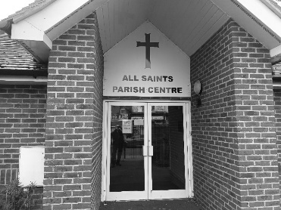
Our modern Church Hall
is available for Hire Monday to Saturday.

Terms and Conditions apply.

£20 an hour.
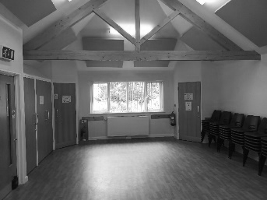
Car park at rear
(access from Coopers Road DA11 7AS)

Access from Perry Street

Contact Angela on 07598 160 937

Parish Priest  Post Vacant | Churchwarden  Garth Fisher  07359 138 267 |  | Churchwarden  Rita Shaw  07734 505 554
Hon Asst Priest  Fr Simon Walker  07794 523 179 | Hon Asst Priest  Fr James Southward  07805 770 042 |  | Hon Asst Priest  Fr Lindsay McKenna
Safeguarding Officer  Susan Johncock  07984 616 906 | Readers  June Skinner  Hilary Turton |  | Hall Bookings  Angela Hill  07598 160 937
Parish Administrator  Martin Hill  07756 736 548  allsaintsperrystreet@gmail.com |  | To book a Wedding or Baptism,  for Lamp sponsorship  and intercessions requests please contact the Parish Administrator.

If you would like to receive our Weekly Bulletin by email,
please email: allsaintsperrystreet@gmail.com

 | The Parish Office,  The Vicarage, Perry Street,  Northfleet, Kent. DA11 8RD. | 

